PSSI Science Project Reporting Template

️ | The PSSI Implementation Team is compiling a technical report to demonstrate the important research and advancements made by the Science Branch through the PSSI funding. The technical report will include a 3-4 page summary (including graphics and figures) for each project to show their key results and findings. Please fill in the following fields and sections for your project to be included in the report. Feel free to include and draw from any reports or presentations previously created through your research.  A plain language science bulletin will also be created to follow up on last year’s “DFO Pacific Region Science Bulletin, 2024. New research and monitoring for Pacific salmon and their ecosystems.” While the first bulletin introduced project backgrounds, methods, and timelines, this new bulletin will highlight the projects’ results, key findings, and conclusions with links to reports and data available. The bulletin will include a 1-2 page summary for each project gleaned from the content entered below.  ️ Completed forms are due January 26, 2026.  *Please include or send separately any graphics or pictures (with photo credits) that will help promote the projects.

PART 1: PROJECT METADATA

General Project Information
Project ID (number) | Project Title
2402 | Quantifying Yukon Chinook migration mortality and its implications for fisheries management and rebuilding under the Fish Stock Provisions of the Fisheries Act
Project Leads | Collaborations and External Partners
Brendan Connors  Adam O’Dell | Alaska Department of Fish and Game  Yukon First Nations
Location (if applicable) | Alaska Department of Fish and Game  Yukon First Nations
Yukon | Alaska Department of Fish and Game  Yukon First Nations

Geographic and Stock Information
Salmon species (if applicable) | Waterbodies (if applicable)
Chinook salmon | Yukon River basin
Life history phases (if applicable) | Region
Adult migrating in freshwater | Yukon
Stock (if applicable) | Population (if applicable)
Yukon Chinook and Porcupine Stock Management Units | Click or tap here to enter text.
Conservation Unit (if applicable)
Porcupine, Northern Yukon, Stewart, White, Pelly, Middle Yukon, Nordenskiold, Big Salmon, Teslin, Upper Yukon

🧰 PART 2: PROJECT METRICS

Project Outputs
Include any anticipated outputs denoted as (in progress). Please include links to any outputs available online so they can be referenced in the report.
List scientific publications and technical reports (with links)
- Glover, L., O’Dell, A. 2025. 2024 Chinook Salmon Radio Telemetry. CRE-185-24N, Yukon River Panel Restoration and Enhancement Fund. (link)
- Connors, B.M., O’Dell, A., Hunter, H., Glaser, D., Gill, J., Rossi, S., and Churchland, C. 2025. Stock status and biological and fishery consequences of alternative harvest and rebuilding actions for Yukon River Chinook salmon (Oncorhynchus tshawytscha). DFO Can. Sci. Advis. Sec. Res. Doc. 2025/nnn. iv + 130 p. (link)
- Challenger, W., Rossi, S., Odell. A., Connors, B.M., Glaser, D., and Glover, L. In preparation. En-route. Mortality Rates of Canadian Origin Yukon River Chinook salmon (Oncorhynchus tshawytscha). DFO Can. Sci. Advis. Sec. Tech. Rep.
List datasets generated (with links)
- Tagging data for individual fish (location, recoveries, associated biological information)
- Raw assessment data (harvest, spawner abundance, age, sex, length), and model based reconstructions, for individual tributaries, Conservation Units (CU) and Stock Management Units (SMU).
Describe dataset locations and data management systems
- All tagging and associated biological data will be available at a public GitHub repository under the Pacific-salmon-assess organization when project is complete in March 2026.
- All assessment data are available at https://github.com/Pacific-salmon-assess/yukon-CK-ResDoc
List code, programs, or other software created (with links)
- All code to fit statistical models to tagging data and draw inference will available at a public GitHub repository under the Pacific-salmon-assess organization when project is complete in March 2026.
- All code to reconstruct Yukon Chinook dynamics, calculate migration mortality in Alaska, assess stocks status is available at https://github.com/Pacific-salmon-assess/yukon-CK-ResDoc
List communication or social media products
- Project Bulletin: Quantifying Yukon Chinook migration mortality and its implications for fisheries management and rebuilding under the Fish Stock Provisions of the Fisheries Act – Pacific Salmon Science
- PSSI Featured Story: Understanding the fate of Yukon River Chinook salmon in their 3,000 kilometre migration journey
List and describe field work completed
- Tagging: Colleagues at Alaska Department of Fish and Game tagged and biosampled fish (i.e., length, age, sex, genetic stock identification [GSI]) at Pilot Station near the mouth of the Yukon River in Alaska. Forty-eight Chinook salmon were tagged in 2023 and 182 Chinook Salmon were tagged in 2024.
- Tower construction and monitoring: Radio receiver towers were constructed in the Canadian portion of the Yukon River and/or reactivated each spring. Four were initially constructed in 2023, and a total of 20 were constructed for 2024, including 13 by DFO and 7 by Yukon First Nations. Data was retrieved from tower receivers each fall, and towers were winterized. Towers were installed at strategic locations throughout the drainage to best capture fish movements into Conservation Units.
- Aerial tracking: In 2023, five days of aerial tracking surveys were completed, flying over 4,000 km. In 2024, 12 days of aerial surveys were completed, flying over 15,000 km. These surveys extended detection range beyond the towers and into the vast sub-drainages of the Yukon River.
- Habitat: Temperature loggers were deployed near telemetry stations to collect water temperature data in remote areas of the drainage.
List and describe samples collected/analyzed (number of samples)
- 48 fish were tagged and sampled in 2023 and 182 fish in 2024
- 10 temperature loggers were deployed
List and describe large capital assets or equipment acquired
N/A

PART 3: WRITTEN CONTENT

Highlights
Please summarize in 2-3 bullets:
- The main idea of the project
- Key findings
- Implications of these findings for salmon and decision-makers
- For a more technical audience, but still as plain language as possible
- Yukon River Chinook salmon returns have remained critically low in recent years, causing immense hardship for Yukon river communities that have relied on salmon for subsistence, cultural practices, and food security for generations.
- The causes of these declines are likely multifactorial; however, in recent years, large numbers of returning adults have gone “missing” during their freshwater migration in Alaska. This has raised concerns that mortality may be occurring after assessment programs enumerate Chinook passage from Alaska into Canada, potentially undermining the efficacy of fisheries management measures.
- An international collaboration among DFO Science, Yukon Rivers Transboundary Area, Yukon First Nations, and the Alaska Department of Fish and Game tagged and tracked adult Chinook during their freshwater spawning migration to quantify migration related mortality.
- Insights from this work can be used to inform precautionary buffers for a border passage goal (i.e., to account for post-border mortality) and in season management of total mortality (fishing and environment) all to support rebuilding and recovery efforts.
- More broadly, the project has established significant infrastructure and catalyzed collaborations that will support continued monitoring and assessment for at least three more years.

Background
Please provide 1-2 paragraphs to summarize
- The relevant biological, environmental, and/or management context
- What knowledge gap or demand were you trying to fill?
- Collaboration and partner relationships
Returns of Chinook Salmon to the Yukon River have been declining for over 30 years, with 2020 – 2024 seeing five of the lowest returns of Canadian-origin Chinook Salmon on record (Figure 1, Figure 2a). Coincident with these declines, substantial en-route freshwater migration mortality has been observed in some years before fish reach Canada. Estimates from assessments sites near the river mouth and at the international border suggest that, in certain years, more than 40% of Canadian-origin Chinook may have died prior to reaching Canadian waters (Figure 2b).

Estimates of natural mortality during the spawning migration in Canada are not available. As a result, fisheries managers work under the assumption that annual spawning escapement is equal to border passage minus any in-river harvest. Given the high levels of mortality observed in the Alaskan portion of the drainage in some years, this assumption has become increasingly tenuous and if violated has the potential to severely undermine fishery management measures and rebuilding and recovery. To help fill the knowledge gap, DFO Science and the Yukon Rivers and Transboundary Area partnered with the Yukon First Nation Salmon Stewardship Alliance (supported by Council of Yukon First Nations), Yukon First Nations, and the Alaska Department of Fish and Game to tag and track the fate of adult Yukon River Chinook salmon throughout their extensive freshwater spawning migration.

️ Methods and Findings
Please insert a few paragraphs to summarize:
- Main methods used
- Products and tools produced
- Advancements in methodology, technology, and application
- Advancements in communication and knowledge transfer
- Key results and information generated
This project complimented tagging, telemetry tracking, and statistical models to estimate spawning migration mortality, alongside assessment of stock abundance and Conservation Unit (CU) status. Details of the latter are described in Connors et al. 2025 and here we briefly describe the tagging components of the work.

Adult Yukon River Chinook salmon were tagged in the lower Alaskan portion of the Yukon River in 2023 and 2024. Migration rates and fate of tagged fish were monitored using a network of remote tracking stations (RTS) deployed throughout Alaska and the Yukon Territory, supplemented by aerial telemetry surveys. Tissue samples were collected from each tagged fish and analyzed by the DFO Molecular Genetics Lab to assign individuals to Canadian Yukon River CUs. These genetic assignments identified the CU each fish was expected to reach. Tagged fish were also aged by the Alaska Department of Fish and Game ageing lab via scale samples. Sex of individual fish was determined by combined visual and genetic methods.
Remote tracking of Chinook salmon in the Canadian portion of the Yukon River was conducted using ATS R4500 receivers deployed at RTS sites. Beginning in 2023, DFO deployed four RTS: three along the mainstem Yukon River and one on the Porcupine River near Old Crow. During 2024, monitoring expanded substantially through a coordinated effort between DFO and the Yukon First Nations Salmon Stewardship Alliance (YFNSSA), undertaken with guidance from Yukon First Nations. This collaboration resulted in the deployment of 20 RTS towers across the basin (Figure 3). The RTS were strategically positioned throughout the Canadian drainage to monitor fish passage at key assessment locations. Stations at Dawson City and Rampart House detected Chinook salmon entering the Yukon Chinook Stock Management unit (SMU) and the Porcupine Chinook SMUs, respectively. Each RTS consisted of a 20 ft tall aluminum mast with antennas mounted at the top to maximize detection range and was installed on elevated riverbanks. Solar powered systems enabled continuous, autonomous operation throughout the migration period. The RTS network provided high-resolution data on movement patterns, timing, and fate of tagged Chinook salmon.
Aerial telemetry surveys were conducted using a Maule M-7 fixed wing plane flying at 300–600 m altitude and approximately 160 km hr ⁻¹. An ATS R4520 receiver was operated onboard with dualH antennas mounted to the wings. Flights followed the Yukon River mainstem and its major tributaries to detect tagged fish. Aerial surveys expanded spatial coverage and provided finer-scale movement information, including identification of migration dropouts and verification of spawning locations, thereby enhancing the spatial resolution and completeness of the telemetry dataset.
A hierarchical Bayesian mark-recapture model is in development to estimate survival by river segment and CU. This framework explicitly accounts for imperfect detections, small sample sizes, and uncertainty in genetic assignments. It will be used to derive annual and multi-year estimates of migration mortality by CU in relation to environmental conditions experienced during spawning migrations.
Preliminary analysis of the tagging data suggest Yukon Chinook migrate at an average of 51 km d⁻¹ (range 38-63 km d⁻¹ ), and the furthest distance travelled was over 3200 kms. In 2024, an estimated 85% of tagged Chinook likely reached their assigned CU spawning grounds. This compares to an estimate of 84% survival of migrating Chinook in the Alaskan portion of the river (as estimated by sonar projects at the river mouth and Yukon/Alaska border) in 2024 which is remarkably similar. If this relationship persists in subsequent years, in-season estimates of migration mortality derived in Alaska may help inform expected migration mortality in Canada and support development of precautionary buffers for bilateral border passage goals under the Yukon River Agreement.

Insights
Please insert a few paragraphs to summarize:
- What this project has added to knowledge about salmon populations, health, or ecosystems.
- How this project informs salmon management:
  - decisions
  - policy guidance
  - trade-offs
  - planning
- Addition of knowledge to understanding:
  - limiting factors/stressors/threats/ pathways of effects/risks
  - biologically significant thresholds
  - cumulative impacts
- Sources of uncertainty
This project has helped develop infrastructure, and catalyze international science based collaboration, to understand the ecology of spawning migration in Yukon Chinook that undergo one of the longest freshwater migrations of any Pacific Salmon. Through tagging, tracking, and statistical analyses we have started to be able to shed light on rates of freshwater migration and the magnitude of spawning migration mortality, by Conservation Unit. These insights can then be related to analysis that characterize population dynamics, estimate biological benchmarks, assess Conservation Unit statuses, and quantify expected biological and fishery consequences of current and alternative harvest management measures for Yukon Chinook.

The establishment of a network of water temperature monitoring stations that this project helped establish will help support water temperature monitoring for years to come and linking freshwater conditions to migration mortality.

Preliminary analyses suggest migration mortality can be well estimated by Conservation Unit and that tagging and telemetry based estimates of mortality in the Canadian portion of the river basin correlated with sonar based estimates in the Alaskan portion of the river. If this pattern holds with more years of data annual estimates of migration mortality in the Alaskan portion of the river can be used in-season to adjust expected migration mortality in the Canadian portion of the river and inform precautionary buffers for the border passage goal used bilaterally under the Yukon River Agreement.

⏩ Next Steps
Please insert 1-2 paragraphs to summarize:
- Remaining knowledge gaps and recommendations for future studies
- How can/should the project findings be operationalized for salmon conservation and management?
Key next steps include:
- development of hierarchical Bayesian mark-recapture models to estimate survival by river segment and CU in a statistically integrated manner that accounts for imperfect detections, small sample sizes, and uncertainty in genetic assignments and that can be scalable to incorporate future years’ data.
- continued tagging and tracking over at least three additional years, in collaboration with Yukon First Nations and the Alaska Department of Fish and Game, will expand sample sizes and strengthen inference across CUs and environmental conditions.
- leveraging the insights from continued assessment to inform in-season precautionary buffers for border passage goals that reflect expected migration mortality in Canadian portion of river after Chinook salmon migrate past border.

📈 Tables and Figures
Please provide captions and numbering for any tables and figures. Graphics can be copied below or e-mailed separately.
- Include a brief caption with each figure and table in the box below
- Number each table and figure, and include references in the above sections where appropriate.
- 1-3 figures are recommended per project
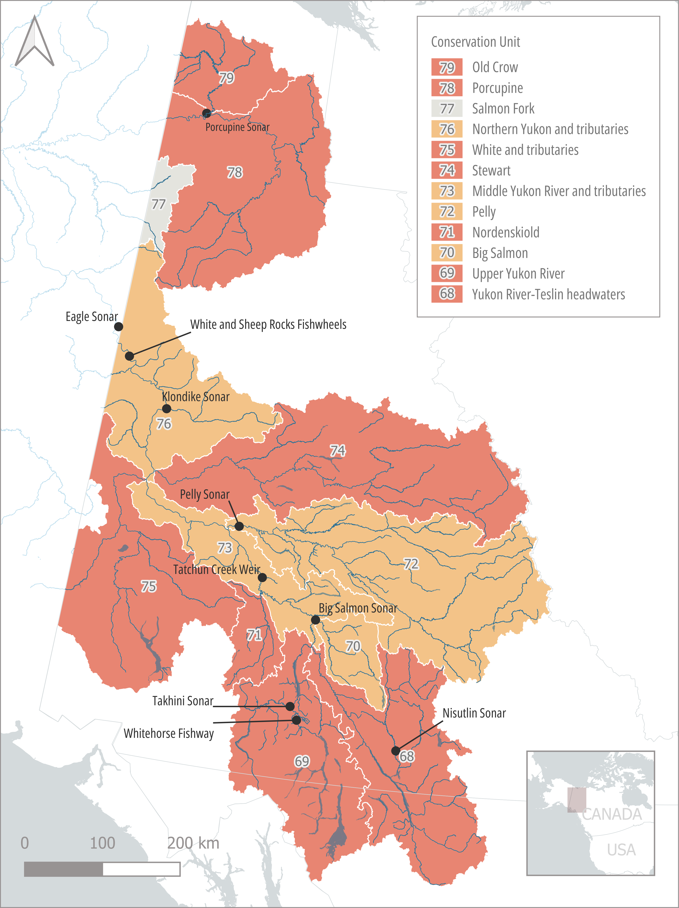
Figure 1. Yukon River Chinook salmon Conservation Units and their corresponding Wild Salmon Policy biological statuses, as well as major contemporary adult assessment sites. Biological status are based on assessment described in Connors et al. 2025.

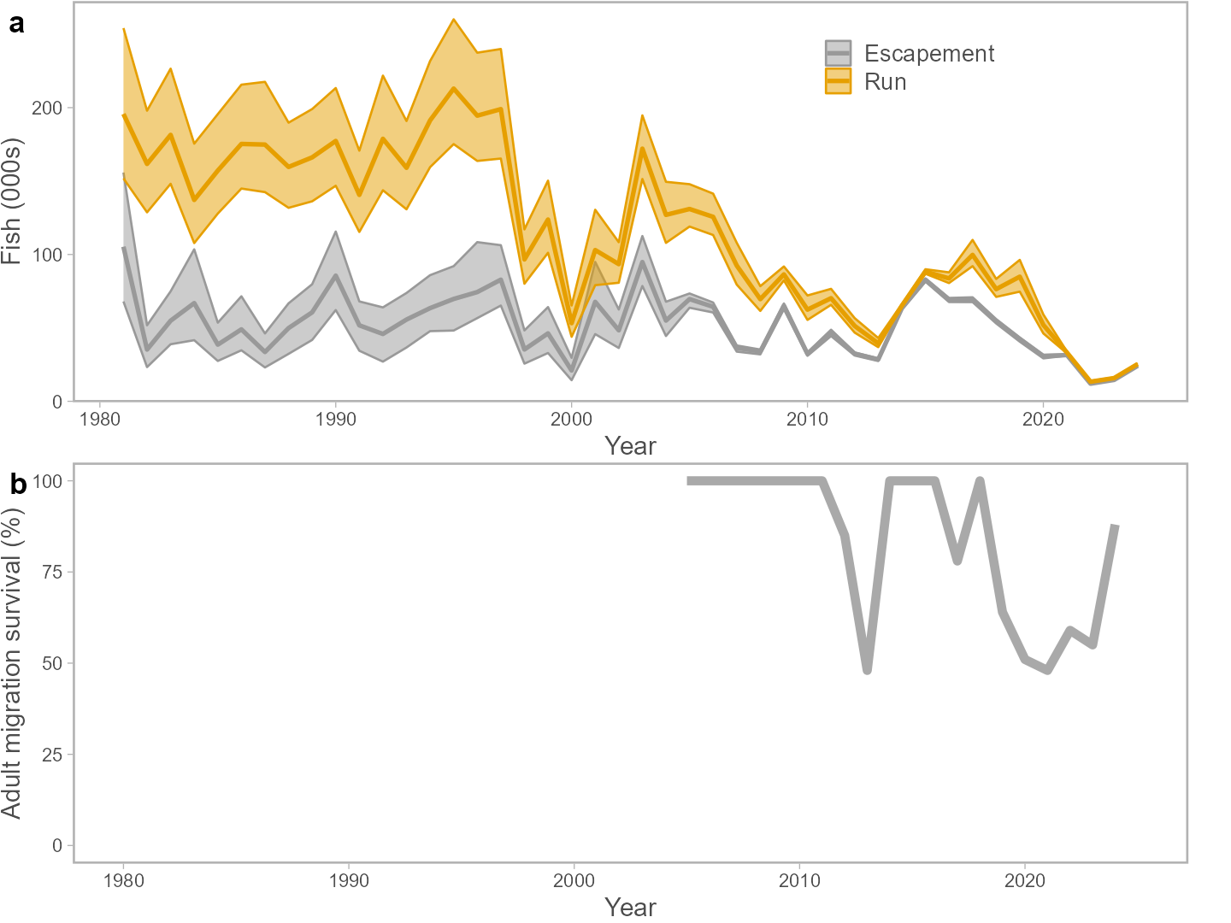
Figure 2. (a) Reconstructions of total returns, and spawning escapement, of Canadian-origin Yukon Chinook and (b) estimates adult freshwater migration survival between Pilot Station (near mouth of river) and Eagle (at Alaska-Yukon Territory border) sonar assessment sites for years where it was estimable (2005 to present).

Figure 3. Yukon River Chinook Salmon Conservation Units and locations of the 2024 remote tracking stations.

Figure 4. Yukon River Chinook Salmon Conservation Units and location of aerial tracking detections of tagged Chinook Salmon and their individual genetic assignments.

📈 References
Include full references for any publications referenced in other sections. Please format references in Harvard style according to Instructions to Authors for the Canadian Journal of Fisheries and Aquatic Sciences, at Canadian Science Publishing.
Connors, B.M., O’Dell, A., Hunter, H., Glaser, D., Gill, J., Rossi, S., and Churchland, C. 2025. Stock status and biological and fishery consequences of alternative harvest and rebuilding actions for Yukon River Chinook salmon (Oncorhynchus tshawytscha). DFO Can. Sci. Advis. Sec. Res. Doc. 2025/nnn. iv + 130 p. (link)

